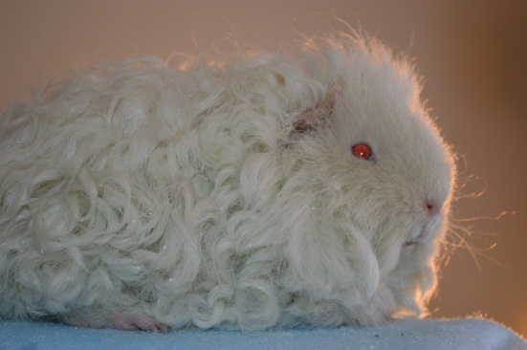
Serendipity Cavies
Birth and Weight Record

Litter Number: ________ Paired: ________ Delivered:_____________
Sire: _________________ Breed: ________ Color: ________________
Dam: _________________ Breed: ________ Color:________________
Live Births: _____________ Still Births:____________
Baby Name/  Ear # | Color/Markings | Gender | Breed | Date | Mass in Grams
Serendipity Cavies
Cavy Treatment Record

Name: ______________________ Gender: _____ DOB: _______
Color: ____________ Ear Tag: _________ Breeder: _______________
DVM name: ____________________ Address:____________________
Phone:___________________ Website:_______________________

Date | Issue | Response

